Experiment 1:

Aim:
To create a “Hello World” Android application that displays “Hello World!” in the center of the screen.
Files used:
- activity_main.xml → Creates the user interface.
- MainActivity.java → Loads the interface.
1. Create the Project
In Android Studio:
- Open Android Studio.
- Select New Project.
- Select Empty Views Activity.
- Give the project name: HelloWorld.
- Select Java as the language.
- Click Finish.
Your project will contain:
HelloWorld
└── app
└── src
└── main
├── java
│ └── MainActivity.java
└── res
└── layout
└── activity_main.xml
2. activity_main.xml
Open:
app → res → layout → activity_main.xml
Replace its contents with:
<?xml version="1.0" encoding="utf-8"?>

<androidx.constraintlayout.widget.ConstraintLayout
xmlns:android="http://schemas.android.com/apk/res/android"
xmlns:app="http://schemas.android.com/apk/res-auto"
xmlns:tools="http://schemas.android.com/tools"
android:layout_width="match_parent"
android:layout_height="match_parent"
tools:context=".MainActivity">

<TextView
android:id="@+id/helloText"
android:layout_width="wrap_content"
android:layout_height="wrap_content"
android:text="Hello World!"
android:textSize="24sp"
android:textStyle="bold"
app:layout_constraintTop_toTopOf="parent"
app:layout_constraintBottom_toBottomOf="parent"
app:layout_constraintStart_toStartOf="parent"
app:layout_constraintEnd_toEndOf="parent" />

</androidx.constraintlayout.widget.ConstraintLayout>
The four constraints:
Top → Parent
Bottom → Parent
Start → Parent
End → Parent
place the TextView exactly in the center of the screen. This is the same basic approach used in standard Hello World Android examples.
3. MainActivity.java
Open:
app → java → your package name → MainActivity.java
Use:
package com.example.helloworld;

import android.os.Bundle;

import androidx.appcompat.app.AppCompatActivity;

public class MainActivity extends AppCompatActivity {

@Override
protected void onCreate(Bundle savedInstanceState) {
super.onCreate(savedInstanceState);

setContentView(R.layout.activity_main);
}
}
Important: If your package name is different, keep the package name that Android Studio has already generated instead of using com.example.helloworld.
The important statement is:
setContentView(R.layout.activity_main);
It tells Android to display the activity_main.xml layout when the application starts.

4. Expected Output in Emulator
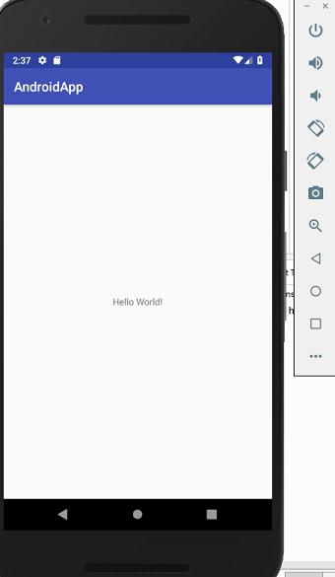
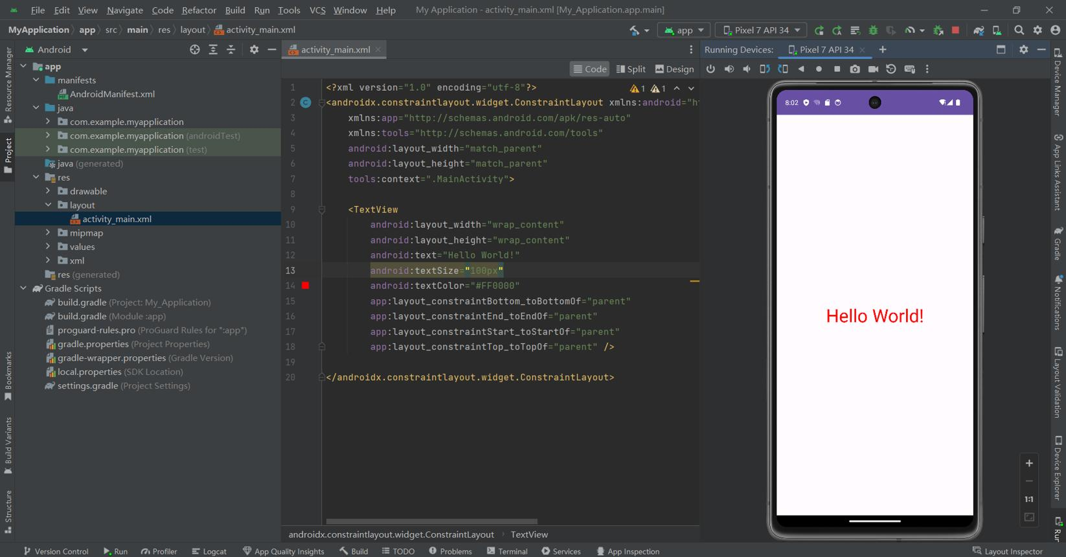
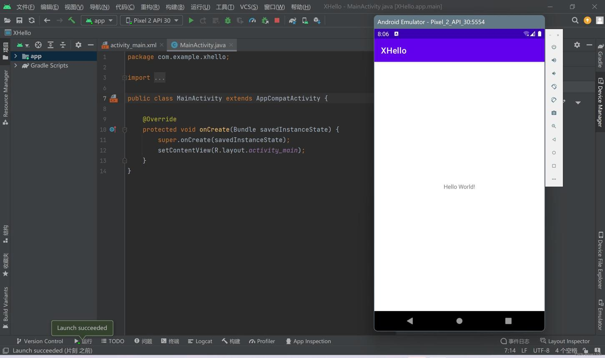
5
Your emulator should look approximately like this:
┌─────────────────────────┐
│ │
│ │
│ │
│ Hello World! │
│ │
│ │
│ │
└─────────────────────────┘
A real Android Studio/emulator example showing Hello World! centered on the phone screen is available here.
5. Run on Android Emulator
- Open Device Manager in Android Studio.
- Create/start an Android Virtual Device (AVD), for example a Pixel device.
- Select the emulator from the device list.
- Click the Run ▶ button.
- Wait for the application to build and install.
Android's introductory documentation similarly uses Run → Run app and then selects an available emulator as the deployment target.
6. Run on Physical Android Phone
To display the same Hello World! application on an actual Android phone:
On the phone:
- Open Settings.
- Go to About Phone.
- Tap Build Number about 7 times to enable Developer Options.
- Go back to Settings.
- Open Developer Options.
- Enable USB Debugging.
- Connect the phone to the computer using a USB cable.
- Accept the Allow USB debugging? message on the phone.
- In Android Studio, select your phone from the device dropdown.
- Click Run ▶.
The application will install on the phone and display:
Hello World!
in the middle of the screen.

